INSURANCE PRODUCT MODELING

TEAM 13
LIAM CAWLEY, SEAN FULCHER, GRAY NICO, SASHA VOLODIN

17th November 2025

Table of Contents

Overview………………………………………………………………………………………………………………………………………….. 1
Methodology……………………………………………………........................................................................................... 1
Data Preparation……………………………………………………………………………………………………………………….. 1
Analysis……………….……………………………………………………………………………………………………………………………. 1
Random Forest Model………………………………………………………………………………………………………………. 1
XGBoost Model………..………………………………………………………………………………………………………………... 3
Results & Recommendations…….………………………………………………..………………………………………………….4
Conclusion…………………………………..……….…………………………………………………………………………………………..4
Appendix…………………………………………………………………………………………………………………………………………..5

INSURANCE PRODUCT MODELING

Overview
The Department of Customer Services and New Products at the Commercial Banking Corporation (hereinafter referred to as the “Bank”) wants to predict which customers will buy a variable rate annuity product. The Bank requests a model that prioritizes accuracy over interpretability. Our team compared a Random Forest (hereinafter referred to as “RF”) and an XGBoost model. We recommend that the Bank utilize the XGBoost model based on its ability to correctly distinguish who will or will not buy the product 88.8% of the time.

Methodology
This section outlines our data preparation for RF and XGBoost modeling.

Data Preparation
For this phase of the project, our team utilized a training dataset with 8,495 observations. Each row represents an existing customer who was offered the annuity product. The target variable indicates whether the customer purchased the insurance product or not. Customer attributes were organized into 37 additional variables, and any numeric variable with ten or fewer distinct values was treated as categorical (excluding “branch of bank”).
All missing variable values were imputed using the median, and 15 additional flags were added as variables to indicate when a value was imputed in their corresponding column (resulting in 52 total predictors). Preliminary variable selection was not necessary, as the Bank already identified the appropriate candidate predictors. We assumed independent observations and no significant multicollinearity between the pre-selected predictors.

Analysis
This section describes the development and evaluation of the RF and XGBoost models.

Random Forest Model
Our team began with an RF model for tuning simplicity. The initial RF model used default values of 500 trees, all 52 predictors, and seven splits. We used this model to calculate the reduction in mean squared error (MSE) for every additional tree, and used the tuneRF function in R to identify the optimal split number. From these approaches, we determined that 250 trees sufficiently minimized MSE, and that seven splits adequately balanced bias and variance.
We also created a random continuous variable (which should have zero correlation with the target variable) to guide our variable selection. If a model predictor was less important than the random variable, it was excluded from the next model iteration. We ranked predictors based on mean decrease accuracy (MDA), which is the number of additional observations that would be misclassified if the corresponding predictor were removed.
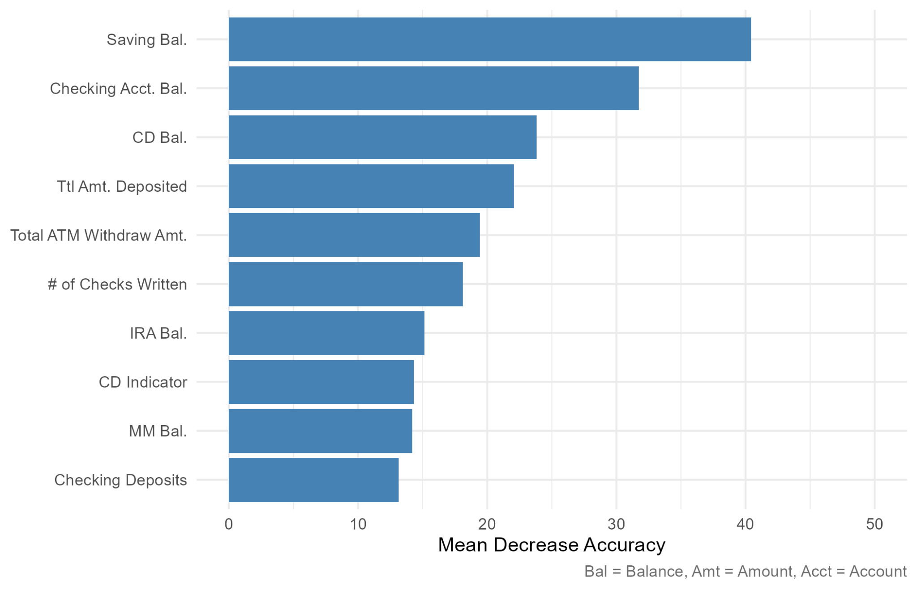
Our final RF model excluded the following predictors: local address indicator, length of residence (and its corresponding flag for imputed values), an indicator for a safety deposit box, the number of insufficient fund issues, and the amount of insufficient funds. Figure 1 visualizes the MDA of the top ten predictors included in the final RF model.

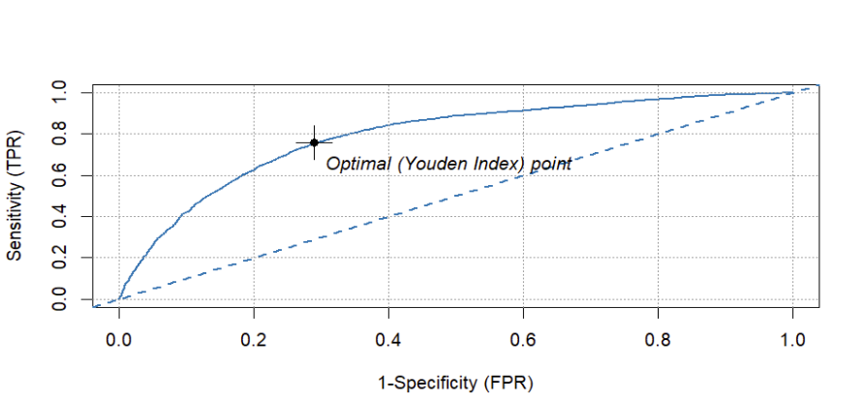
From Figure 1, we see that a customer’s savings balance, checking account balance, certificate of deposit (CD) balance, total amount deposited, and total amount of ATM withdrawals are the strongest RF predictors for whether that customer will buy the annuity product or not. Figure 2 visualizes the ROC curve of this model to identify the optimal cutoff for RF predictions.
Figure 1: Importance of final RF model predictors based on mean decrease accuracy

Figure 2: ROC curve for final RF model
Based on the optimal cutoff value from Figure 2, we classified any prediction with a probability greater than or equal to 0.35 as a 1, and 0 otherwise. This model had an AUC value of 0.791, which indicates that it correctly ranks positive cases over negative cases 79.1% of the time.

XGBoost Model
Our team also developed an XGBoost model to enhance accuracy. Since XGBoost models require more parameter tuning than RF models, we used a tuning grid (see Figure A1) with 100 trees to determine our best model, rather than manually pruning (as we did with the RF model). The best model considered all 52 features with a learning rate of 0.15; each tree used a bootstrapped subsample with 75% of the training data to split up to four times.
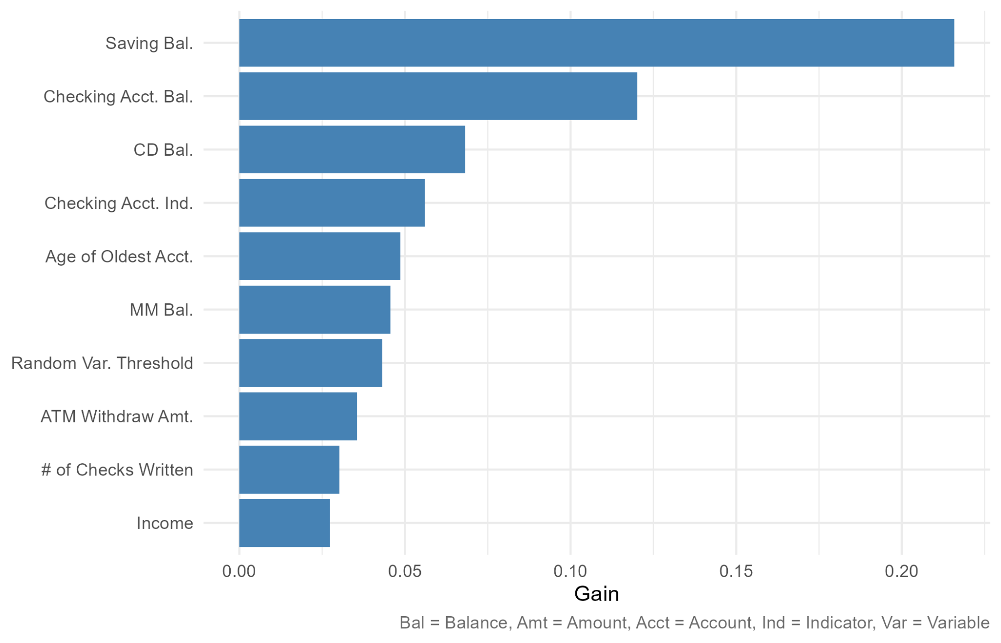
Figure 3 visualizes the top ten features in the best XGBoost model, ranked by gain. This measure differs from out-of-sample accuracy, and can be interpreted as the relative increase in model purity every time the corresponding feature is used in a split.

Figure 3: Importance of final XGBoost model predictors based on gain
Based on Figure 3, we can see that model classification is most improved by considering a customer’s savings balance, checking account balance, CD balance, whether they have a checking account, and the age of their oldest account. This result is very similar to what Figure 1 showed, with a customer’s savings account balance, checking account balance, and CD balance also appearing as the top three most important features. Therefore, Figures 1 and 3 can help the Bank identify the most valuable attributes for predictions.
Figure 4 visualizes the ROC curve of this model to identify the optimal cutoff for the XGBoost model’s predictions.
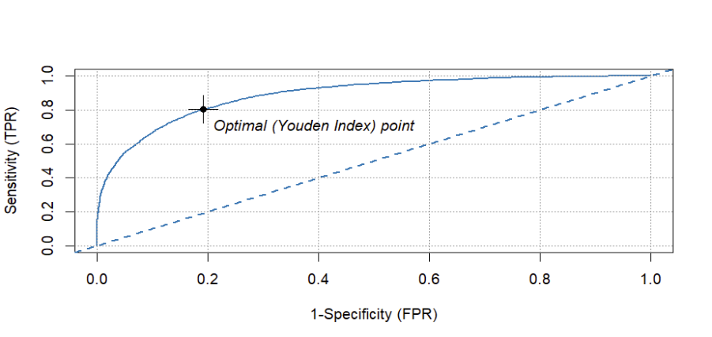

Based on Figure 4, we classified any prediction with a probability greater than or equal to 0.37 as a 1, and 0 otherwise. This model had an AUC value of 0.888, which indicates that it correctly ranks positive cases over negative cases 88.8% of the time.
Figure 4: ROC curve for final XGBoost model

Results & Recommendations
To determine the better model, our team calculated four performance metrics for comparison. As shown in Table 1, the XGBoost model outperforms the RF model in all measures.
Table 1: Summary of both models’ performance metrics using ROC values.
Model | True Positive Rate | False Positive Rate | AUC | Specificity
Random Forest | 76.62% | 28.71% | 79.20% | 46.91%
XGBoost | 80.47% | 19.24% | 88.89% | 61.23%
Based on these performance metrics, our team recommends that the Bank use the XGBoost model with all 52 features, a learning rate of 0.15, and 75% of the training data in each tree’s bootstrapped subsample for up to four nodes per tree.

Conclusion
Despite the XGBoost model’s greater computational demands and parameter specifications (compared to the RF model), its ability to correctly rank predictions 88.8% of the time makes it the best option for the Bank. By examining the overlap between both models’ most valuable features, the Bank would find that the top five most important attributes are a customer’s savings balance, checking account balance, CD balance, total amount deposited, and total amount withdrawn from ATMs. With this information, the Bank will be better equipped to make more informed and targeted marketing efforts to maximize returns.
Appendix
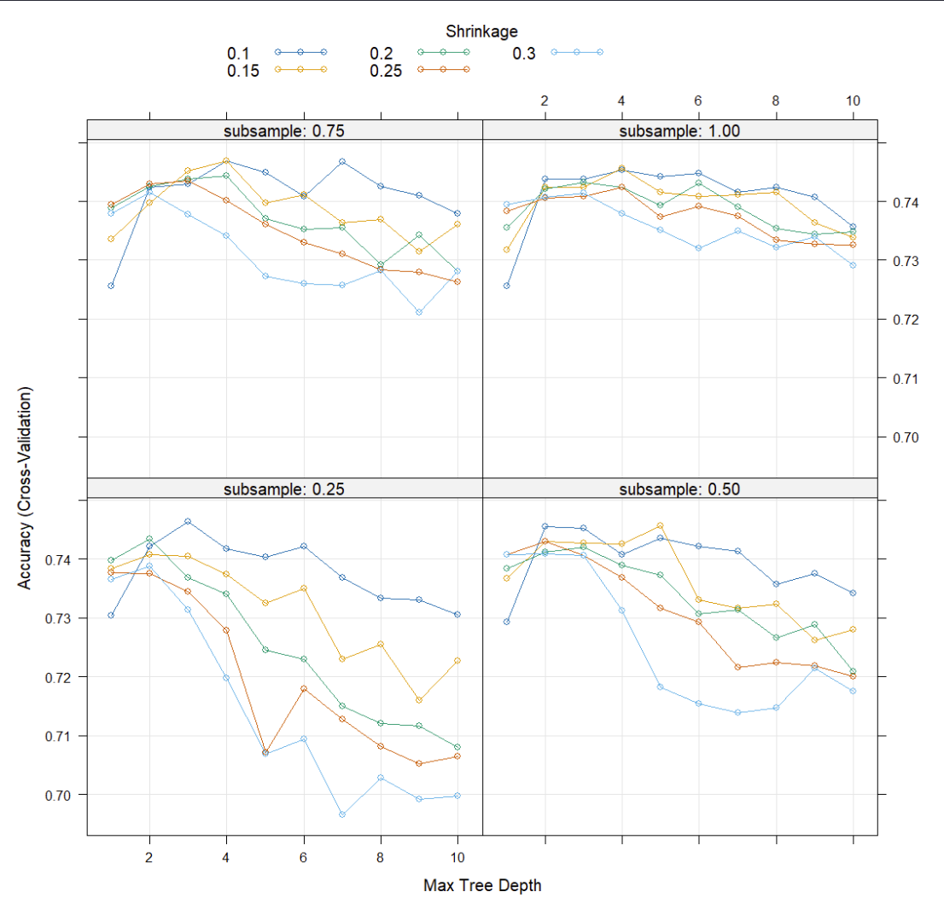

Figure A1: Full tuning grid for XGBoost parameters (using 100 trees)

